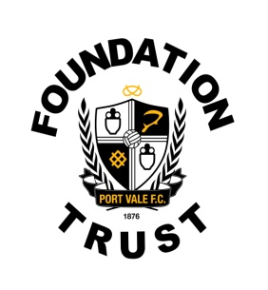
PORT VALE FC FOUNDATION TRUST

PERSON SPECIFICATION

Job Title: | Female Football Development Coach | Date: June | 2018
Salary: Volunteer

FACTOR | ESSENTIAL | HOW ASSESSED | DESIRABLE | HOW ASSESSED
(1) Relevant Experience | Previous experience of running Coaching courses to the governing bodies standards.  Previous experience of leading coaching sessions in a team/ competitive environment.  Experience in match day environments at grass roots level. | Interview/ CV | Prior knowledge of working on diverse projects and project management.  Prior experience of working within the female game. | CV / Interview
(2) Formal Academic Qualifications |  |  | GCSE Maths, English and ICT | CV/Certificates.
(3) Vocational Qualifications and Training | National coaching qualification endorsed by the sport’s governing body.  Health and Safety at Work. First Aid & Safeguarding.  FA licensed coach member | CV/certificates & Interview.
(4) Specialist Knowledge | Level 1 certificate in coaching football.  FA Youth Module 1 award | CV/certificates. | Level 2 certificate in coaching football.  Other NBG awards | CV/Certificates.  Interview.
(5) Job Related Skills and Abilities | Must be able to communicate effectively with participants, customers, visitors and staff.  Good IT skills, including word processing, spreadsheets and databases  The ability to work under own initiative and be pro-active in driving the organisation forward. | Interview / CV
(6) Physical Requirements and Personal Attributes | To represent Port Vale Foundation Trust in a professional manner at all times; to include dress, presentation, hygiene, attitude, conduct and professionalism | Interview/references. | Enthusiasm and passion for sport  A positive attitude towards professional development and their own learning  Creative in problem solving situations together with a willingness to take on or try new approaches and ideas | Interview / CV
(7) Special Working Conditions | Have a clean enhanced DBS check.  Hold a valid full, clean UK driving licence.  Required to work evenings and weekends and occasional match days.  Reliable approach to working hours | Interview/ CV

