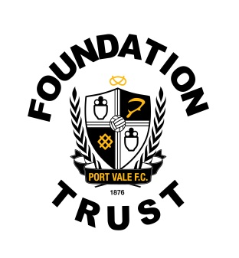

VACANCY: School Sports and Participation Officer
Port Vale Foundation is an independent and registered charity working in partnership with Port Vale Football Club.
Our mission statement for Port Vale FC Foundation is: ‘To create opportunities through football and sport / recreation to engage, motivate and inspire people from all sections of our community, helping them to fulfill their potential.’
Port Vale FC Foundation is looking to appoint a school sports and participation officer to join the developing foundation team throughout its community programmes.
You will act as the central point of contact for schools at PVFC Foundation. The post-holder will be responsible for overseeing a portfolio of high-quality sport and educational programmes for schools, both during curriculum time and extra-curricular activity.
The role will be responsible for developing and implementing the Premier League (PL) Primary Stars programme for children aged between 5 and 11 in primary school settings.
Please see attached the job and person specification.
Closing date for the all applications is Thursday 13th December 2018 5pm with all interviews taking place wk commencing 17th December 2018.
For more information or to apply for the position please send a completed application form to Port Vale FC Foundation Trust, Port Vale Hamil Road, Burslem, Stoke-on-Trent, Staffs, ST6 1AW or via email to foundation.trust@port-vale.co.uk

