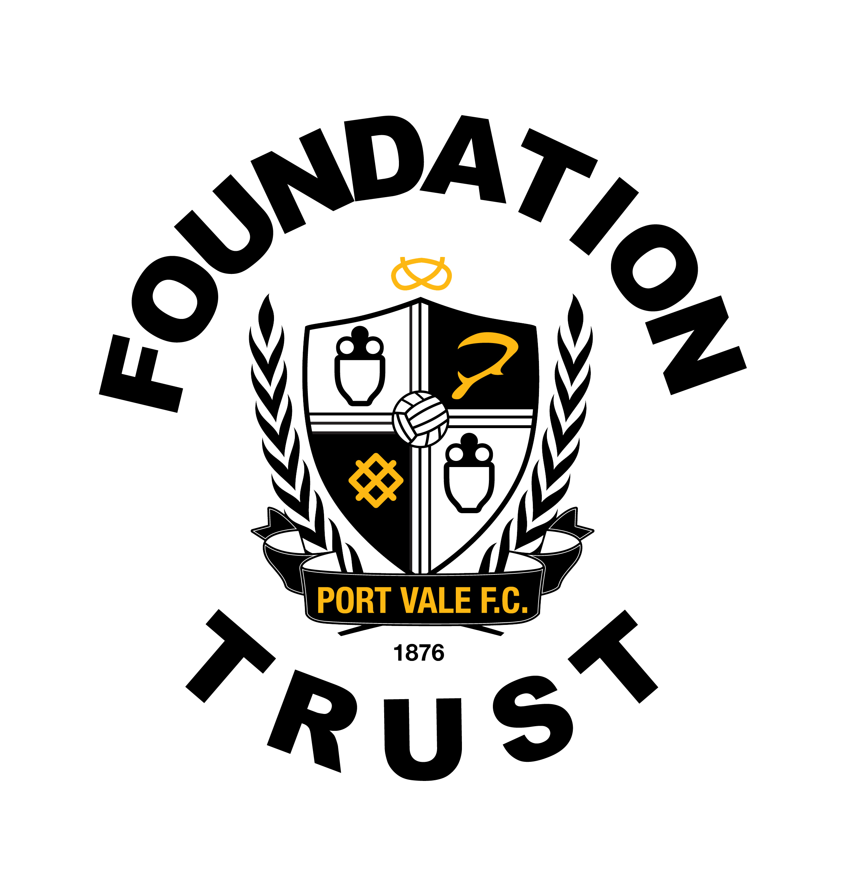
PORT VALE FC FOUNDATION

PERSON SPECIFICATION

Job Title: | Community Sports Coach | Grade: | Casual Agreed Rate
 |  | Date: | 2018

FACTOR | ESSENTIAL | HOW ASSESSED | DESIRABLE | HOW ASSESSED
(1) Relevant Experience | Previous experience in delivering / leading curriculum time lesions.  Previous experience of running Coaching courses to the governing bodies standards. | Interview/ CV | Experience in delivering in a school environment such as PE / Lunch time and after school clubs. | CV / Interview
(2) Formal Academic Qualifications |  |  | GCSE Maths and English. | CV/Certificates.
(3) Vocational Qualifications and Training | National coaching qualification endorsed by the sport’s governing body.  Health and Safety at Work. First Aid & Safeguarding. | CV/certificates & Interview. | FA licensed coach member | CV / Interview
(4) Specialist Knowledge | Level 1 certificate in a NGB award. | CV/certificates. | Other level 2 NGB awards  AFPE Level 3 | CV/Certificates.  Interview.
(5) Job Related Skills and Abilities | Must be able to communicate effectively with participants, customers, visitors and staff.  Good IT skills, including word processing, spreadsheets and databases  The ability to work under own initiative and be pro-active in driving the organisation forward. | Interview / CV
(6) Physical Requirements and Personal Attributes | To represent Port Vale Foundation Trust in a professional manner at all times; to include dress, presentation, hygiene, attitude, conduct and professionalism | Interview/references. | Enthusiasm and passion for sport  A positive attitude towards professional development and their own learning  Creative in problem solving situations together with a willingness to take on or try new approaches and ideas | Interview / CV
(7) Special Working Conditions | Have a clean enhanced DBS check.  Hold a valid full, clean UK driving licence.  Required to work evenings and weekends and occasional match days.  Reliable approach to working hours | Interview/ CV

