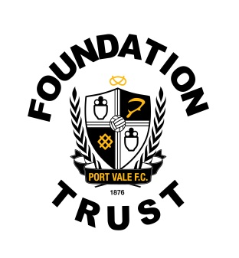

VACANCY: FOUNDATION CASUAL COMMUNITY COACH

Port Vale Foundation is an independent and registered charity working in partnership with Port Vale Football Club.
Our mission statement for Port Vale FC Foundation is: ‘To create opportunities through football and sport / recreation to engage, motivate and inspire people from all sections of our community, helping them to fulfill their potential.’
Port Vale Foundation is looking to appoint a number highly motivated part time coaches to join the developing foundation team throughout its community programmes on a casual basis.
You will be involved in the delivery across all themes the foundation delivers. These include Sports participation, Football Development, Education, Social Inclusion, Health and Disability.
All successful candidates must hold a minimum NGB level 1 sporting qualification, an in date FA safeguarding protecting children and First Aid certificate. All coaches will be required to be a member of the FA licensed coaches club holding an enhanced DBS certificate or subject to an enhanced DBS check prior to commencing.
The candidate must understand the importance of planning, delivering and evaluation projects and have a passion for community engagement through the vehicle of a professional Football Club.
For more information or to apply for the position please send a copy of your CV and completed application form to Port Vale FC Foundation Trust, Port Vale Hamil Road, Burslem, Stoke-on-Trent, Staffs, ST6 1AW or via email to foundation.trust@port-vale.co.uk
Tel: 01782 757066

