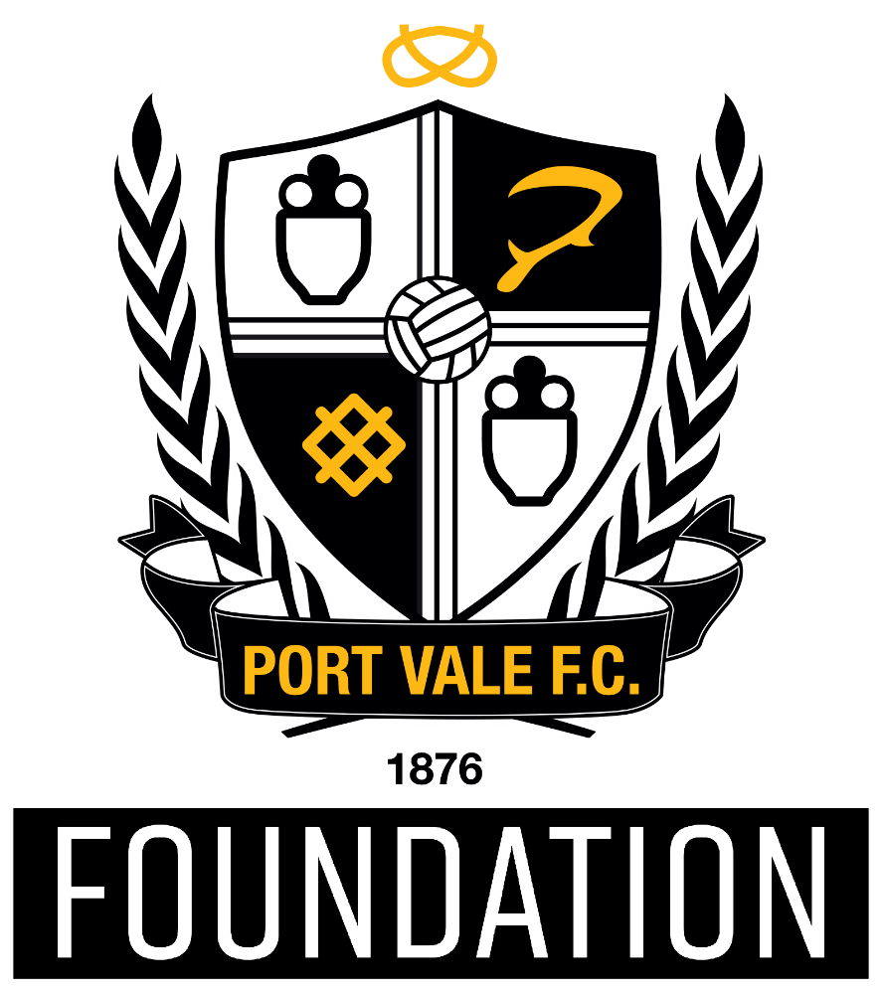

Lead coach

Port Vale Foundation use the power of Port Vale Football Club to create opportunities to engage, motivate and inspire people to improve their lives and their communities.
We are a values led organisation and strive to live and breathe them each and every day. Our values are:
- Passionate – We are passionate about supporting the people of Stoke on Trent and Staffordshire to improve their lives and their communities
- Collaborative – We foster and develop innovative partnership with wide ranging organisations to maximise our impact and outcomes
- Integrity – We use a robust evidence base and proven practice to inform decisions, measure impact and sustain our activity
- Inclusive – We create opportunities for everyone from every background to take part in our programmes and have positive experiences, which lead them to fulfil their potential
- Excellence – We provide high quality experiences and support for participants, partners, professionals and staff
- Proud – We celebrate success and are visible to everyone, meaning we are valued by our club, our partners and our community.
In order to fulfil our mission, we are actively looking to contribute to local, regional and national priorities, using the Port Vale Football Club Foundation brand to positively impact on a range of agendas such as increasing sport and physical activity, improving health, increasing education standards and improving community cohesion.
To focus and influence the Port Vale FC Foundation in achieving our mission whilst supporting and tackling local priorities, our work is categorised under four core areas:
- Sport & Physical Activity
- Health & Well-being
- Education & Employability
- Community Engagement

Under each of our areas, we also identify a number of priorities for Port Vale FC Foundation Trust that are aligned to various local, regional and national plans and strategies – ensuring that our work contributes to the wider strategic context for Sport, Health, Education and Inclusion.

Role Profile – Lead Coach

Role Reports to: Operations Manager and Department Managers

Hours: 37.5 hours (fixed term) Pay scale: Grade 4 @ £17,374.50 - £19,500
The Role: Lead Coach
Port Vale Foundation is an independent and registered charity. We use the power Port Vale Football Club to create opportunities through the power of the football club to engage, motivate and inspire people from all sections of our community, helping them to fulfill their potential.

To support the strategic growth of Port Vale FC Foundation, we are looking to appoint a highly motivated, skilled and passionate individual to become one of our Lead Coaches.

Our coaching activity is diverse and spans across schools based, community based and football specific delivery of coaching.

We believe the added accountability in the role is a perfect next step for coaches who are looking to expand their skills beyond delivery, taking responsibility for the development of activities, supporting school and community relationships and mentoring apprentice coaches.
Main Responsibilities and Accountabilities
- To lead and supervise all participants in the coaching and delivery sessions ensuring compliance with standards of the National Governing Body and in line with Port Vale Foundation values

- To assist department lead staff and project staff in the planning and delivery of Port Vale Foundation community projects across all themes of delivery, which include health and wellbeing, education, community engagement and schools

- To assist department lead staff and project staff in the maintenance of high-quality relationships with stakeholders and parents

- Delivery of a high quality extra-curricular programme, linking participants wider PVFC Foundation opportunities, including football player pathway and age appropriate opportunities
- .
- Deliver high quality physical education lessons across the national curriculum and governing bodies

- Deliver high quality football development coaching sessions across all community football activities

- To be confident and qualified to give first aid treatment where necessary

- To deliver high quality coaching sessions during half term holiday camps

- Lead by example by creating exceptional session delivery plans and always delivering to the highest standards

- To ensure the correct procedures are adopted in the event of an emergency

- To keep registers of all participants stored safely and support the department lead with recrding, monitoring and evaluation.
Key Skills & Experience
- Experience in supporting the planning, delivery sports coaching programmes

- Experience in working with children and YP.

- Ability to develop and maintain strong relationships with key partners, schools and community based organisations

- The ability to work under own initiative and demonstrate Port Vale Foundation values every day.

- Flexible to work evenings and weekends around the needs of the Foundation.

- Proficiency with Microsoft Office package and excellent IT skills

- Excellent verbal and written communication skills

- Strong time and task management skills
General
- Demonstrate the values of Port Vale Foundation at all times and adhere to all policies and procedures in the employee handbook

- Ensure maintenance of a professional appearance to include dress, presentation, hygiene, attitude and conduct

- To be aware of and comply with current Health and Safety Regulations and the Foundations Health and Safety policy and procedures as they relate to the duties and responsibilities of the post

- To undertake any appropriate training as required

- To maintain awareness of risks and feed these into the formal risk management process and also to control the risks inherent in your job and report any risk concerns to your manager

- To undertake any other duties that may be reasonably allocated to the post holder commensurate with the grading and responsibilities of the post

- To be aware of our Company Policies and Procedures which may be updated from time to time; to ensure that your actions and behaviour are consistent with and champion the requirements of those policies and procedures at all times.

Person Specification – Lead Coach

 | Essential/Desirable | How Assessed
Relevant Experience
Previous experience Delivering/Leading curriculum time lessons. | Essential | Interview/Application
Experience in delivering high quality EYFS, KS1, KS2 PE lessons. | Essential | Interview/Application
Previous Experience of running coaching courses to governing body standards. | Essential | Interview/Application
Previous Experience of delivery in community coaching sessions. | Essential | Interview/Application
Delivering Larger (Whole School) Learning Activities | Desirable | Interview/Application
Evaluating impact of sessions | Desirable | Interview/Application
Formal Academic Qualifications
GCSE Maths and English C+ | Essential | Application
AFPE Level 3 | Desirable | Application
Further Education around Sports Coaching and Development | Desirable | Application
Degree in a sport/educational related subject | Desirable | Application
Vocational Qualifications and Training
National coaching qualification endorsed by the sport’s governing body | Essential | Certificates/Interview
First Aid & Safeguarding Certificates | Essential | Certificates/Interview
Enhanced DBS Check | Essential | Certificates/Interview
FA Licensed Coach Member | Desirable | Certificates/Interview
Health & Safety at Work | Desirable | Certificates/Interview
Specialist Knowledge
Level 2 Certificate in a Sporting NGB Award/s | Essential | Certificates/Interview
Good Knowledge of current PE school curriculum and OFSTED guidelines | Essential | Certificates/Interview
Other level 2 NGB Awards | Desirable | Certificates/Interview
Multi Skills Level 2 | Desirable | Certificates/Interview
Job Related Skills and Abilities
Be able to communicate effectively with participants, customers, visitors and staff | Essential | Interview
Good IT Skills, including word processing, spreadsheets and databases | Essential | Interview
Ability to deliver KPIs against project plans on time and within budget | Essential | Interview
Ability to work under own initiative and be pro-active in driving the organisation forward | Essential | Interview
Physical Requirements and Personal Attributes
To represent Port Vale Foundation Trust in a professional manner at all times; to include dress, presentation, hygiene, attitude, conduct and professionalism | Essential | Interview/References
Enthusiasm for the job | Essential | Interview
A positive attitude towards professional development and their own learning | Desirable | Interview
Creative in problem solving situations together with a willingness to take on or try new approaches and ideas | Desirable | Interview
Special Working Conditions
Have a clean enhanced DBS check. | Essential | Interview
Hold a valid full, clean UK Driving licence. | Essential | Interview
Required to work evenings and weekends and occasional match days when requested. | Essential | Interview
Reliable approach to working hours | Essential | Interview/References

If you would like to apply for this role please complete an application form that can be found at www.portvalefoundation.co.uk/job-vacancies

Email the completed application form to foundation.trust@port-vale.co.uk or you can send it by post to:

Job Vacancies
Port Vale Foundation
Vale Park
Hamil Road, Burslem
Stoke-on-Trent, ST6 1AW

If you require any more information, please call us on 01782 757066.

